**Run Server Django**

Go to folder with manage.py (see Django create project.docx):

**Run server command:**

python manage.py runserver

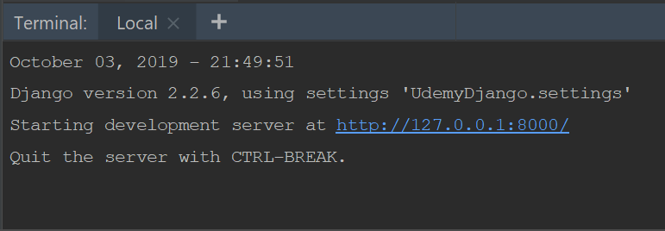

**EXIT FROM RUNSERVER:**

CTRL + C (in pycharm terminal)